**Assignment 2: SP Anomaly**

**Name : ROHAN KUMAR**

**Roll No: 17EX20022**

**Link to the original Code:** <https://colab.research.google.com/drive/1YGzY3Au9aTBYOwcDrCaonBULLLyAW-FZ>

import numpy as np #importing libraries

import matplotlib.pyplot as plt

import math

print('Enter different parameter values:’) #taking input from user

k= float(input('Enter qualitative dipole moment in mV:'))

h=float(input('Enter depth to the centre of sheet from surface in m:'))

a=float(input('Enter one-half of the length of the sheet in m:'))

alpha=float(input('Enter angle between sheet and horizontal in degree:'))

x0=float(input('Enter the value of x0'))

Enter different parameter values: #default input parameters

Enter qualitative dipole moment in mV:50

Enter depth to the centre of sheet from the surface in m:50

Enter one-half of the length of the sheet in m:40

Enter angle between sheet and horizontal in degree:0

Enter the value of x0:400

sp=[]        #List of SP anomaly over a sheet type structure

xlist= np.arange(0, 1000, 10)

for x in xlist: #calculating SP anomaly

    V= k*np.log((((x-x0)-a*np.cos(alpha*np.pi/180))**2+(h- a*np.sin(alpha*np.pi/180))**2)/(((x-x0)+a*np.cos(alpha*np.pi/180))**2+(h+a*np.sin(alpha*np.pi/180))**2))

    sp = np.append(sp, V)

sp= sp.reshape(len(xlist))

sp #displaying SP anomaly for given parameters

array([ 15.79914657, 16.15706198, 16.53088619, 16.92163538,

17.33040435, 17.75837233, 18.20680883, 18.67707919,

19.17064967, 19.68909132, 20.23408217, 20.80740638,

21.41094901, 22.04668394, 22.71665179, 23.42292293,

24.16753874, 24.95242076, 25.7792331 , 26.64917593,

27.5626779 , 28.51893939, 29.51525531, 30.54601125,

31.60119534, 32.66419302, 33.70852686, 34.69306435,

35.55505774, 36.20026053, 36.4894526 , 36.22138183,

35.11408415, 32.79060638, 28.7811995 , 22.55837655,

13.61475337, 1.5693482 , -13.73821352, -32.19103601,

-53.31757132, -76.01200981, -97.83818982, -114.38074142,

-121.12928855, -118.14051839, -109.75028618, -99.87827628,

-90.42051996, -81.9929288 , -74.67497632, -68.36549242,

-62.92057559, -58.20128432, -54.08738266, -50.47902924,

-47.29460655, -44.46767748, -41.94409256, -39.6795384 ,

-37.63755423, -35.78795902, -34.10561382, -32.56944915,

-31.1616991 , -29.86729586, -28.67338855, -27.56895881,

-26.54451181, -25.5918265 , -24.70375246, -23.87404385,

-23.09722281, -22.36846653, -21.68351347, -21.038585 ,

-20.43031965, -19.85571775, -19.3120945 , -18.79704019,

-18.30838611, -17.84417548, -17.4026384 , -16.98217026,

-16.581313 , -16.19873893, -15.83323659, -15.48369835,

-15.14910965, -14.82853947, -14.52113197, -14.22609907,

-13.94271397, -13.67030531, -13.40825202, -13.15597871,

-12.9129516 , -12.67867482, -12.45268715, -12.23455902])

import pandas as pd #displaying first 10 SP anomaly as pandas dataframe

df=pd.DataFrame(sp,xlist)

df.columns=['SP Anomaly']

df.head(10)

SP Anomaly

015.7991471

016.1570622

016.5308863

016.9216354

017.3304045

017.7583726

018.2068097

018.6770798

019.1706509

019.689091

plt.plot(xlist,sp,color='red') #ploting SP anomaly v/s profile curve

plt.xlabel('profile distance in m')

plt.ylabel('SP anomaly')

plt.title('SP anomaly v/s profile distance')

plt.savefig('plot.png')

from google.colab import files #downloading plot

files.download('plot.png')

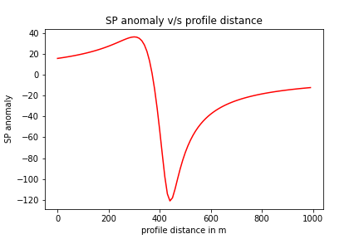

The final image looks like this. It has greater SP Anomaly to the left and lesser to the right of X0. This asymmetry is due to the angle alpha by which the thin sheet is tilted with respect to the horizontal. Similarly, different parameters have different effects on the SP anomaly. Changing them one at a time will give us an idea about it. Let’s change it one by one.

1. **Qualitative dipole moment (k):**

The parameter k affects the magnitude of SP Anomaly. The figures have k=50, k=100 and k=500 respectively. On increasing the value of k, the magnitude of SP anomaly increases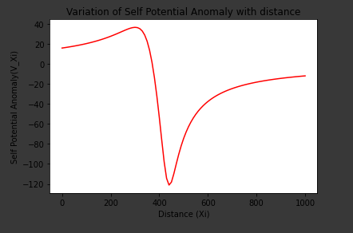 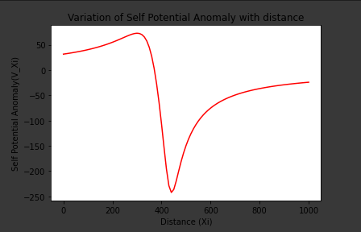

Figure 1: k=50 Figure 2: k= 100

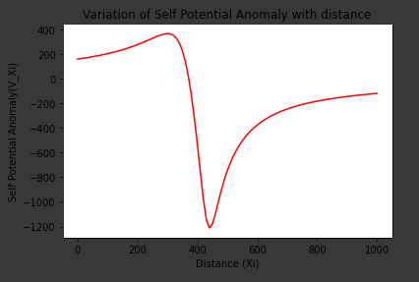 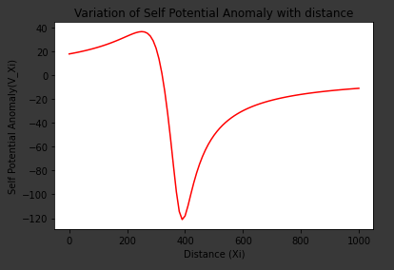

Figure 3: k=500 Figure 4: X0=350

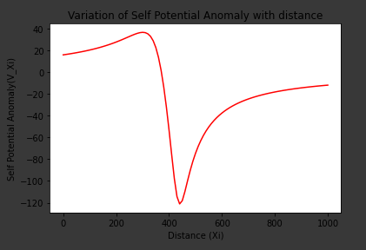 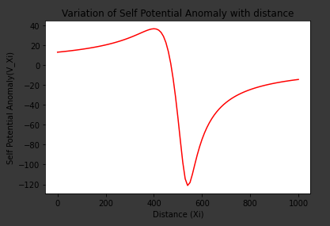

Figure 5: X0= 400 Figure 6: X0= 500

1. **X0:** The lateral shift in the position of the minimum SP anomaly is observed with the change in X0.On increasing X0, a lateral shift towards right is observed.
2. **Depth of the centre of the sheet from surface(h):** As the depth increases, the rate of change of SP anomaly is found to be decreased.

 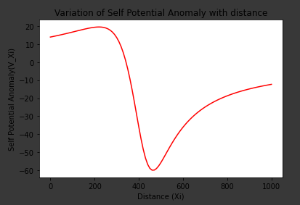

Figure 7: h=50 figure 8: h=100

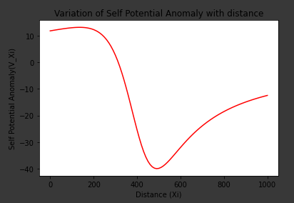 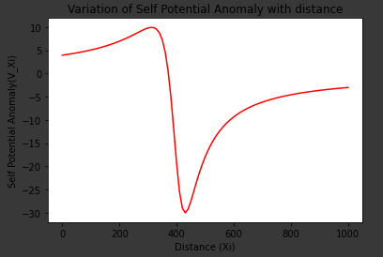

Figure 9: h= 150 Figure 10: a=10

 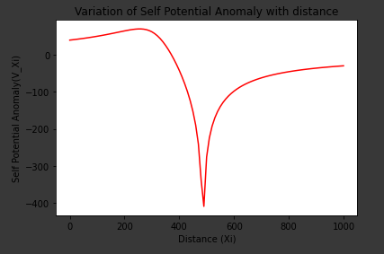

Figure 11: a=40 Figure 12: a=100

1. **Half the length of the sheet(a):** Increase in the length of sheet results in the concentration of SP anomaly at location X0.
2. **Angle between the sheet and the horizon(alpha):** Alpha being the angle between sheet and the horizon, affects the symmetry around X0. If alpha is found to be 0, i.e. sheet is horizontal, then SP anomaly is perfectly symmetric around X0. It gives positive SP anomaly on the left of X0 and negative anomaly on the right of X0. SP anomaly is 0 at X0=0. Further increasing the angle upto 90 degrees results in More SP anomaly on the left side of X0 and less on the right with an inflection point on 45 degrees. Further from alpha between 90 to 180, the SP anomaly on the right has high magnitude the left side.

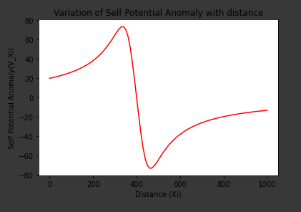 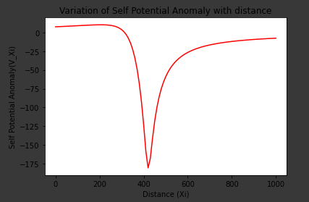

Figure 14: alpha=0 Degree Figure 15: alpha = 60 degrees

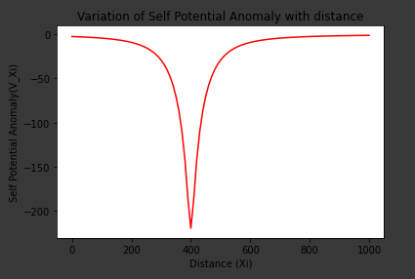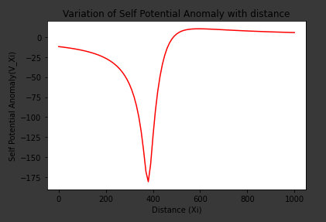

Figure 16: alpha =90 degree Figure 17: alpha = 120 degree